Evaluation
Logo
I designed my logo to be bright and colourful so it would stand out and be noticed. I wanted it to be bright and appeal to the audience because it was to be included in the other documents I made for the controlled assessment. I think that it was suitable for the age group that I aimed it at.
My logo was a yellow smiley face that transforms into the words ‘Get Up, Get Moving’, I used a smiley face as I thought it portrayed the campaign as being a positive thing and the words were coloured black and red so they stood out. It moves quickly and repeatedly and I think it is quite effective.
I received positive feedback on my logo which was ‘I like the way it changes colour and I think the smiley face gives a positive impression.’ Mr McDaid said ‘It’s good, you could change the size of the background and possibly the colour’; as a result to this feedback I changed the background size.

Animation

Multimedia quiz
My quiz was designed to test the knowledge of the person using it; the questions were suitable for my target audience. I included pictures and animations to make it more interesting and appealing. The slides were different colours to make them more exciting to look at and I included a wide range of questions to make the audience think and to test their knowledge. I received positive feedback on the way in which the PowerPoint worked. Zoe said ‘it’s very good’. Sir said ‘Very good’ and just picked out a couple of aspects he thought I could change and I made the changes I thought necessary.
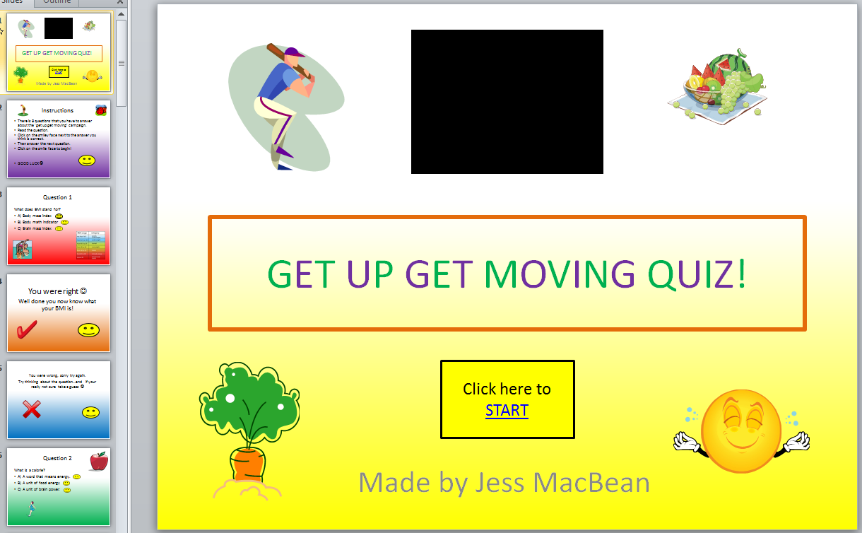
This is the first slide of my quiz; it is interactive so you click on the buttons to navigate throughout the quiz.
I used the colour yellow on the first slide as it is a positive and happy colour. I used bright colours so the writing stood out and pictures to make it more interesting.

Get Up, Get Moving model
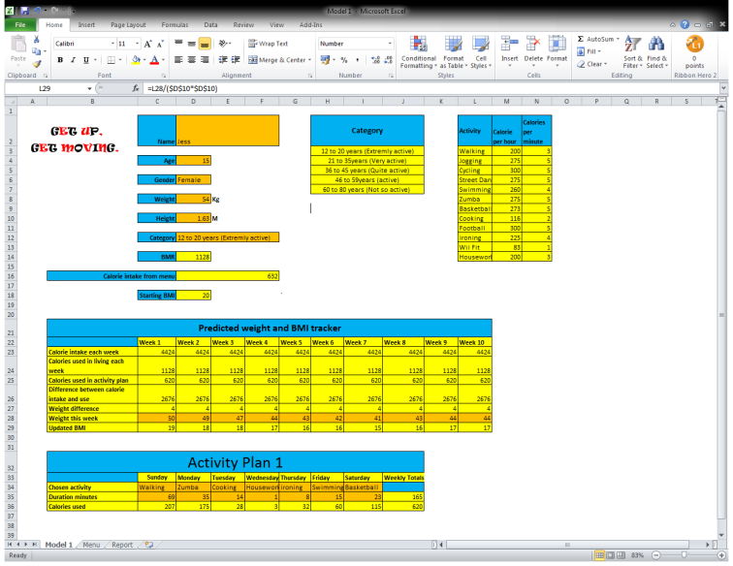
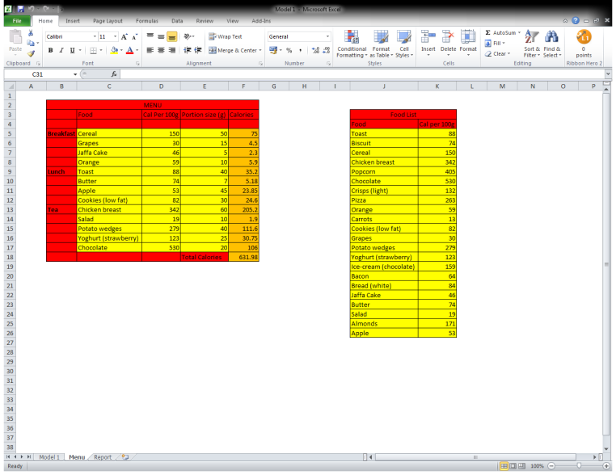
The model I created is easy to use and follow. I used different bright colours to differentiate between the parts of the model the use can input things into and the parts that you have a drop down box and option to choose from. The model is interactive so that the user can add their own information and use it for their self. It has a variety of activities and meals to choose from and is suitable for most ages. Zoe said ‘I was impressed in the way that you used the colours and designed the model.’

These are screen shot of the different pages in my model. I used bright colours to make it appealing to look at and to make it stand out.
The first clipping shows a recommended menu and a calorie list so you can plan what you’re eating and know what’s in it.
The second shows an interactive page that enables you to input data to find out your BMI and you can track it too.
The third shows the plan and its benefits.

Get Up, Get Moving report
This is a personalised report for an individual, it includes their BMI information and a recommended fitness plan that can be followed and its probable impact. I used my own information to show a before and after to show how the campaign works. This also has my logo incorporated into it. It is bright and colourful to catch the attention of the target audience. I think I set it out well and included all of the necessary information. This is also attached to my model. Zoe said ‘It’s well designed and colourful.’
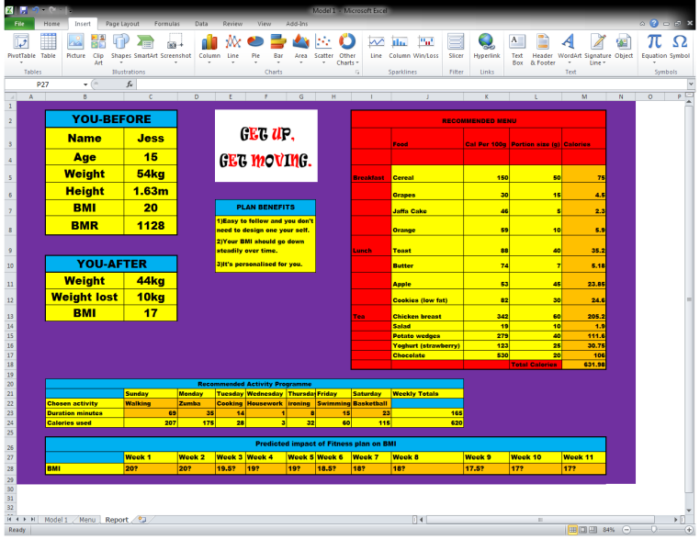

Digital poster The digital poster I created promoted the campaign ‘Get Up, Get Moving’; it was set on a timed loop so it repeatedly played. This also includes a low calorie meal and its picture. I named it ‘What’s for lunch?’ as it made it sound more interesting and I used pictures of healthy meals to promote healthy eating.
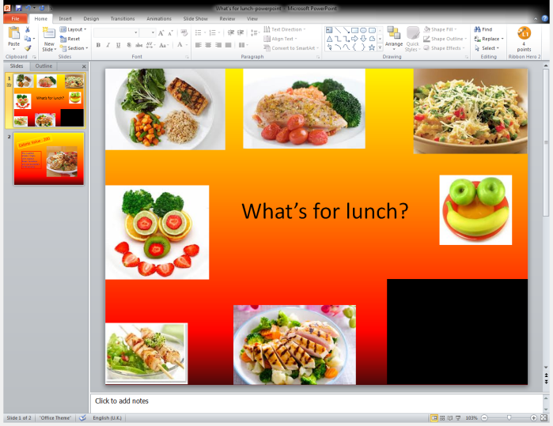
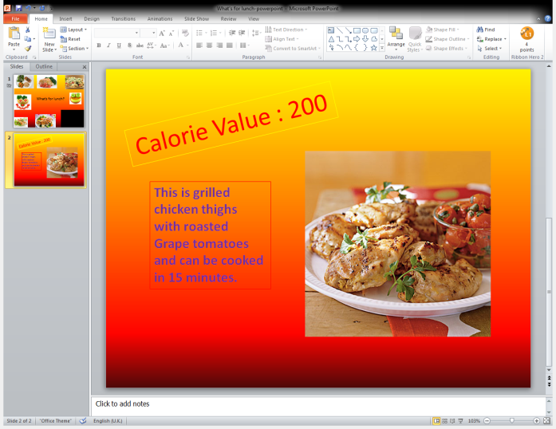

I used bright colours and pictures to make it stand out and look interesting. This also includes my logo (the black box in the bottom right hand corner). I feel it is well aimed at my target audience and promotes healthy eating and awareness of food. Zoe said that ‘I really like the colours which are positive and attract the reader.’
Podcast In my podcast I used a piece of music at the beginning that was lively and interesting to capture people’s interest and I used this same piece at the end of my podcast to round it off nicely. When I wrote the script I tried to make it sound as interesting as I could to help promote the campaign and get people involved. I aimed it at my target audience which is people of my own age and I asked my friends to listen to it and they gave me positive feedback. When I recorded the script, I could have sounded a bit more enthusiastic but I was trying to make sure that I didn’t make any mistakes! Zoe said ‘It’s amazing.’
Website When I designed my website I wanted it to be bright and colourful so it appealed to the sense of sight. I used pictures of people exercising as that linked to the campaign. My title was green and stood out so everyone notices it. My website could have been better but I spent some of the lessons redoing it as I accidentally ruined some of it. As my background I used a picture of some dancers which was colourful with a black background so the pictures merged together and look good. I used blue buttons that linked to the other webpages and when hovered over they ‘ripple’; which added an interesting effect. I also linked my quiz and model to pictures on the website so that people who are interested in the campaign can use them and find out more information. ‘It’s very nice, I like the background and the way you’ve changed the colour of the test so it stands out.’
This is my website home page, I made the title and bright so that the name of the campaign stood out. I also included my logo.
I added pictures of people exercising and a ‘Keep calm and get up get moving’ poster as I though some people may find this inspirational!
My background is a picture of people dancing and I chose it as the backing colour was back and then they blended in together.
The buttons were blue so they stood out and they make a rippling effect when clicked on.
All of the other pages mirror this page but with different information on it.
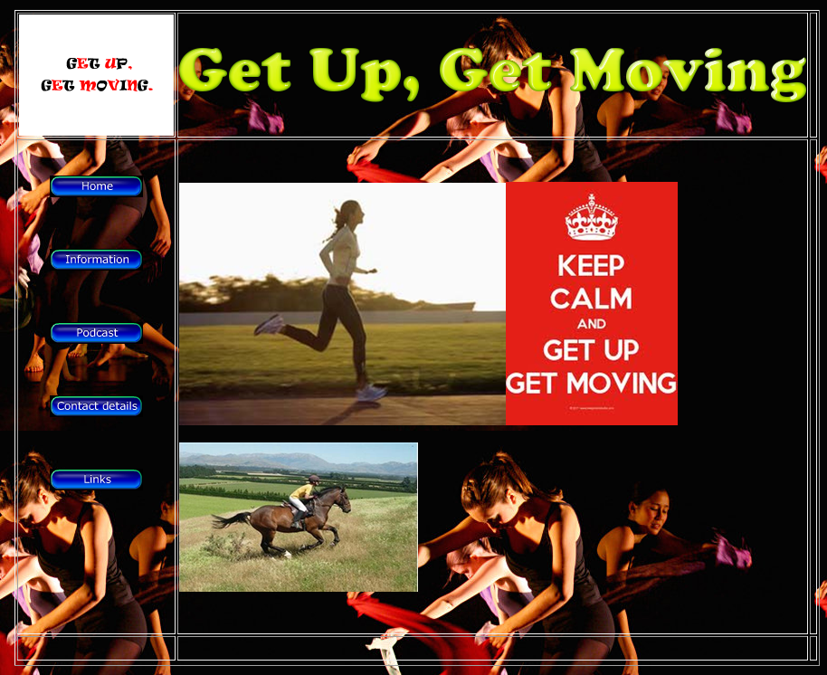

My performance
I think that I managed my time well; I generally completed all of the activities in the set time. I didn’t mess around in the lessons and I planned out my time well. The skills I found most useful during this controlled assessment were: being creative which helped when designing certain aspects of the assessment, good time management as then I completed the work on time and new what I still had to do and my ability to ignore the distractions around me. Whenever I encountered any problems, firstly I would try different ways to overcome them and then I would ask my friends for assistance if that didn’t help and I would only ask my teacher as a last resort.
Some aspects of my project could have been improved if they were slightly more appropriate for the target age, some of my work may seem more appropriate for children than teenagers. Other aspects could have been completed in more detail which may have given me more time to make them look more prefessional.
My work could have been more successful if I hadn’t missed so many lessons, as I would have had more time to complete the work to a better standard. My teacher said that my work was ‘a very thorough and thoughtfully produced project, with excellent attention to detail in every aspect.’
My test buddy said ‘I’m really pleased with Jess’s work, she has worked really hard and I think her work is really good.’ As a test buddy, I could have been more helpful if I had been at school for more of the lessons to support my test buddy; but I helped her whenever I could and gave her truthful advice about her work.

